Distributed systems report

Name- David Dwyer

Student number- A00210554

Sql tables used

I used one table in my project using the code

CREATE TABLE PART (

number VARCHAR(50) NOT NULL,

name VARCHAR(20)NOT NULL,

description VARCHAR(150) NOT NULL,

stock INTEGER NOT NULL);

I added two test objects to the table as shown below.

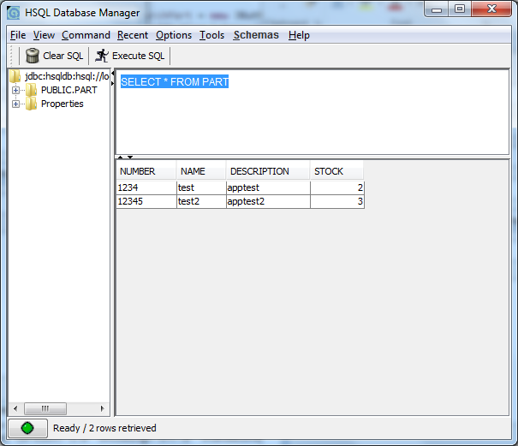

First we run the server which uses sets the url to /parts and uses the first GET function to call the getParts method in PartDao to put the information from the database into an array using the part class. The GET function then takes that information and converts it to xml.

The second GET function sets the url to /parts/(partNumber) and uses the getPart method in the PartDao class and returns the object in the database that has the part number equal to the number enter in the PartNumber field of the url. The GET function then takes that information and converts it to xml.

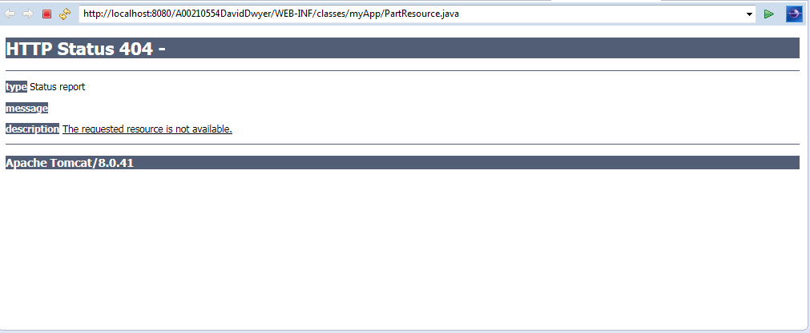

The first button is the list parts button which will run the client code when pressed uses the uri builder to send the /parts url to the first GET function in partResource and then calls the doParseParts method in the ParseParts class which parses the xml output from GET back into an array called partList and then prints the array out in the text area using a for loop and append as shown below.

The second button search part uses the uri builder to send the /parts/partNumber to the second GET function in the partResource where partNumber is the text entered in the textbox to the right of the search part button. It then calls the doParseBook method which converts the xml output from the GET function into a new part object and then displays that object in the text area as shown below.

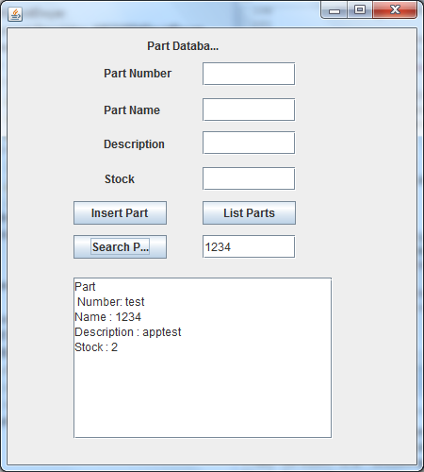

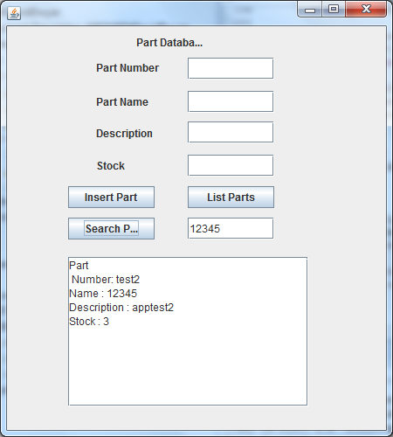

Problems encountered

One function that I could not get to operate properly was the POST function for adding to the database the PartDao method is working but I could get the rest to work. Another problem I had is that when the search part button is used that output has the name and number attributes switched from what they should be I could not resolve this either.